2020-2021 Pennant

Suggested Pennant Administration Best Practices

Welcome to the BDBD Pennant Season for 2021. This season we are joining many regions in Victoria in administering the season via BOWLSLINK.
These BEST practices may vary between clubs. Do let us at the BDBD know if you think you have a better method than those suggested below.

PRE SEASON
The BDBD has completed the fixture for the new season and now it is the Clubs turn to prepare for the upcoming season.
This Diagram depicts BowlsLink Responsibilities you need at your club
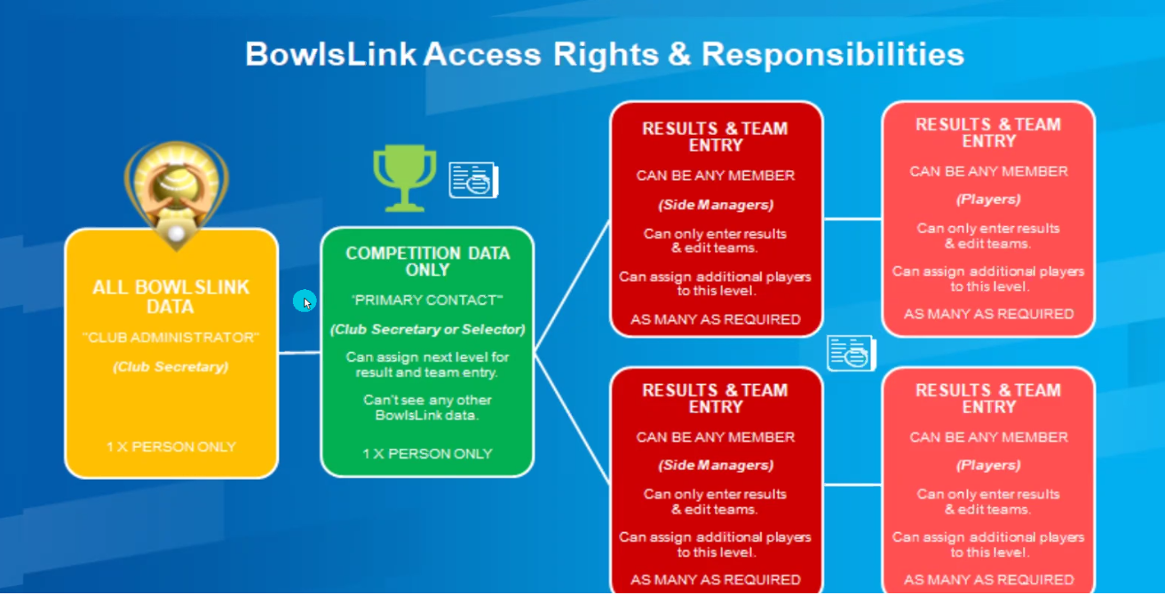
Thing to do include:-
- Determine who are your BowlsLink Administrators (recommend you have 3). Has this changed and do you need to arrange for Bowls Vic to assign other members? TIP: a member of the Match Committee should be allocated as one of the Club Administrators. They will then have the ability to set up competitions in BowlsLink for your club
- Determine who your primary contact for competitions. For this season we have assigned a dummy member. In future seasons you will need to advise BDBD (or its replacement) who your primary contact will be for Pennant
- Determine who you assign to assist in Results and Team Entry – Should have a minimum of two at your club on Pennant day and at least one at the Selectors meeting
- Update your Bowlslink membership database with the financial status of pennant players
- Export your membership list then open in Excel. Delete columns so that you only have the basics
First Name | Last Name | National Id | Mobile Phone Number
Adrian | Graham | 162713 | 0402 054 072
John | Holt | 177323 | 0418 544 963
- Print this and have it available in the office for reference
- Ensure the members responsible for entering teams and the results can Login to Bowlslink and are comfortable with the process (refer to the training materials on the BDBD website)
- Check you have the “dummy” member and password that you may need to use for your initial set up and in an “emergency” i.e. when no one in the home teams has been assigned to Enter Teams/Results
- Check you have cards, labels (optional) Team Sheet (basically a PRF) Team Folders for managers

PRE MATCH/SELECTION
- Select your teams
- For each competition (Division) enter teams in BowlsLink. TIP: In each competition the system will prevent you entering the same player twice but because each Division is set up as a different competition you could inadvertently enter a player in a team in another Comp/Div.
Tip2: If when you “search” for a member – you clicked on the blue box - you cannot find them they would already have been added as a player for this competition. Just use the drop down menu and they should be there.
Tip3: for the next rounds use the import teams feature in the action button at the club level (not the teams level)
- Prepare your match day folders Cards, Team sheet (ex PRF) Labels Pens etc.
- Send teams to Courier as per below
Each club emails pennant teams - NOTE NEW EMAIL ADDRESS
- send to sport.thecourier@austcommunitymedia.com.au
- Saturday pennant deadline - 5pm Thursday
- Tuesday pennant deadline - 5pm Friday
Format for teams -
WEBBCONA
Division 1: B Smith, B Brown, B White, B Black (s); B Smith, B Brown, B White, B Black (s); B Smith, B Brown, B White, B Black (s); B Smith, B Brown, B White, B Black (s)
Division 2: B Smith, B Brown, B White, B Black (s); B Smith, B Brown, B White, B Black (s); B Smith, B Brown, B White, B Black (s); B Smith, B Brown, B White, B Black (s)
Division 3: B Smith, B Brown, B White, B Black (s); B Smith, B Brown, B White, B Black (s); B Smith, B Brown, B White, B Black (s); B Smith, B Brown, B White, B Black (s)
- If Players advise of unavailability one of the members with access to do Results and Team entry can make the change If the player who becomes unavailable was the person assigned to do Results and Team Entry assign another player to do this task or at least ensure this can be managed e.g. The away team manager could call a contact back at the club and have them log in and confirm the results.
- Provided the person has been assigned to do Results and Team Entry and changes can be done on any device that can access the internet i.e. you do not have to be at the Club to make changes.
- Assign umpire(s) and ensure your club and players are aware of Covid Safe practices.

PRE MATCH/PENNANT DAY
- Check if we are playing. If weather conditions could mean there will be no play follow the Adverse weather policy/process and Conditions of Play.
- Home Club prepares for play following Covid Safe Practices for mats jacks etc. and ensuring Sanitiser etc. is available
- Prior to match a club official should announce specific details/practices for the days play
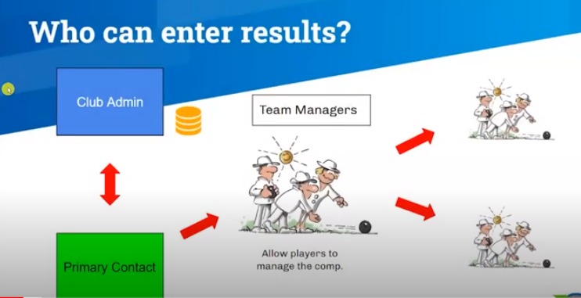
- Team Managers
  - Home Team Managers verify you have access to BowlsLink or identify who is the nominated BowlsLink entry person for the day
  - Have Team sheet card etc. ready
  - Conduct Card draw, Assign Rink Numbers etc., Complete Team Sheet

POST MATCH
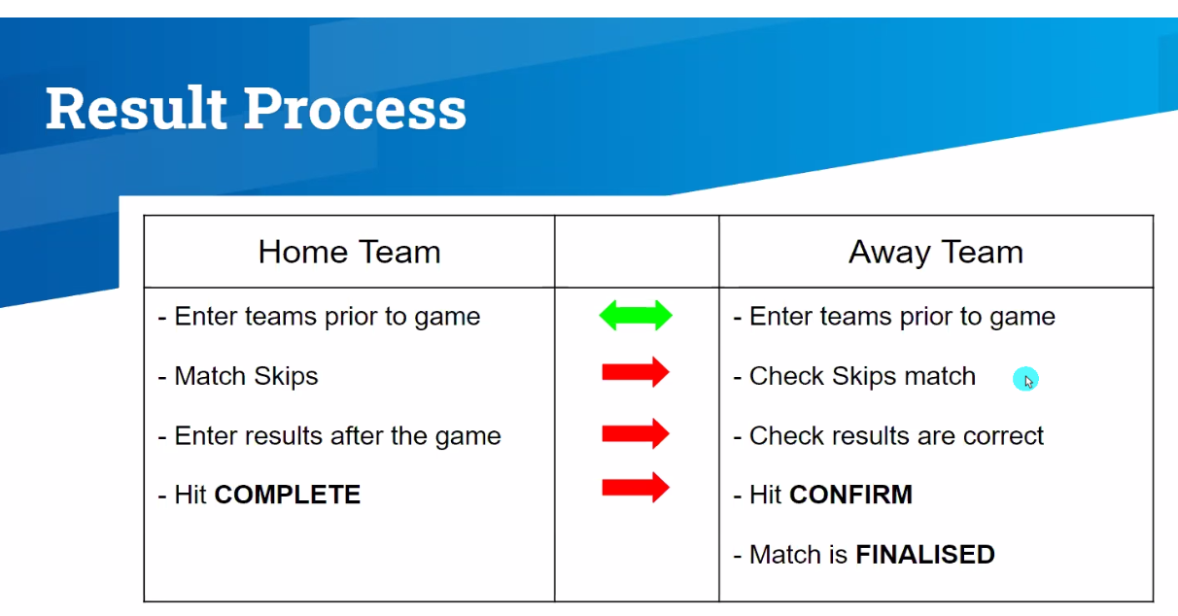
Note: It is preferable the Results Entry is completed at the conclusion of the game. Whilst some clubs when at home may choose to use one or two people to do the entry the Away managers should CONFIRM before they leave either in person or by calling their club contact to do it on their behalf
Tip: Make sure Your Team Manager(s) especially Away have the capability to Enter Teams and Results.
Tip: Have your Team mangers access the bowlslink results page (a link is on the BDBD Pennant page) on their digital device – tablet/phone. Have them SAVE this link so they can bring it up easily. Whilst the Home manger is accessing bowlslink, swapping skips and entering results they can login and be ready to CONFIRM
Tip: Only Home Teams can enter results. So sometimes when you try to enter results and you can’t it is because for that game you are the Away team.

- Team managers
  - Collect cards
  - Complete team sheet (if used)
  - Home team manager/ Bowlslink co-ordinator
    - Match Skips (does away team manager agree?)
edit players if another player was changed on the day
enter results (does away team manager agree?)
    - Hit complete
  - Away Manager
    - Verify cards and team sheet
    - Verify skips on BowlsLink match
    - Verify results are correct
    - Hit CONFIRM
Tip: Managers can always take Pictures on here phones of cards team sheets in case of dispute
Tip: How to enter results for Abandoned Games forfeits etc. are in the Cheat Sheets at the end of this document
- View the results – if you complete the Results entry the results will now be on line. To see the results go to the BDBD website pennant page https://ballaratdistrict.bowls.com.au/pennant/ and click on results
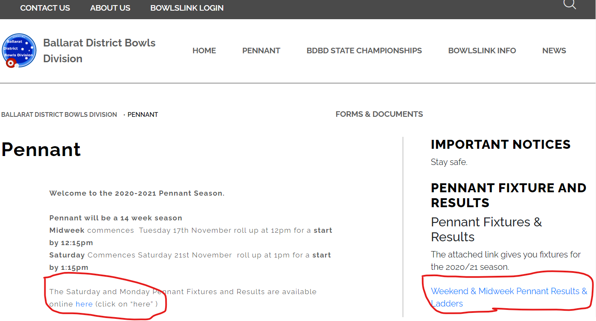
- The BDBD website has all the Bowlslink info (even a link to a bowlslink login) including training guides. You can also Login to Bowlslink via the BowlsLink Results page.
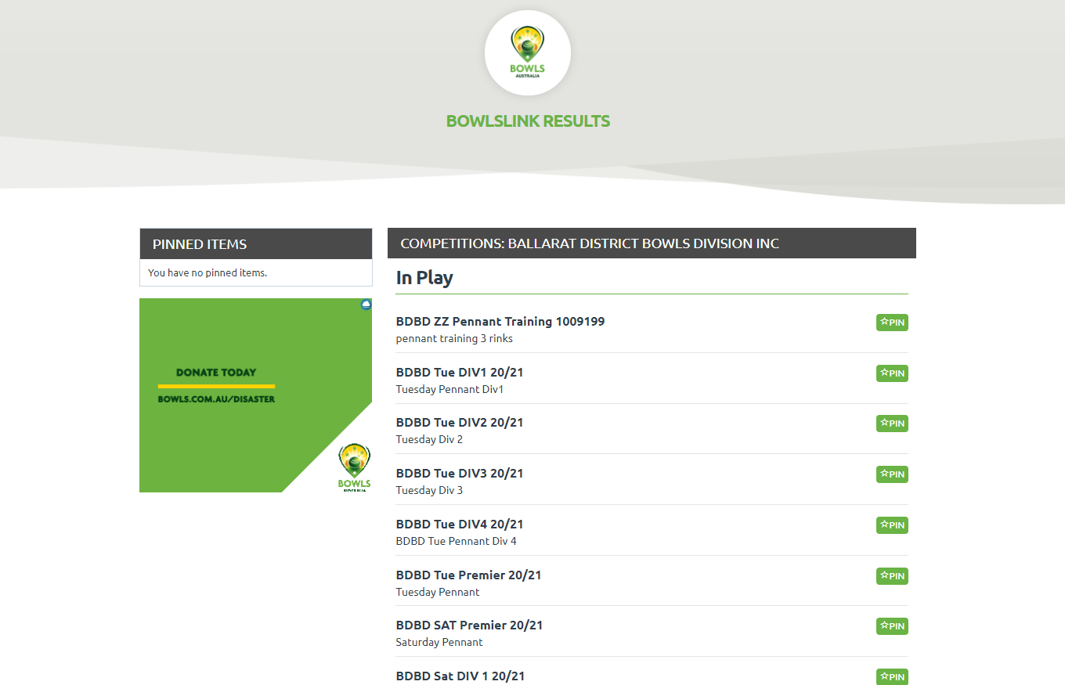
- OOPS.
Mistakes happen and as bowlslink results page allows your members to drill down too player level they will pick them up.
Up to the point the Away Manager hits CONFIRM any mistakes can be rectified by the Home Manager after that, the match is FINALISED.
Email copy of the team sheet/ cards and a note what the problem is about to the BDBD secretary and adjustments can be made.
If for some reason there is no access to Bowlslink notify the BDBD Secretary to discuss.

Thanks for your patience. We hope we have covered everything but if not you can contact
BDBD Secretary or Adrian Graham – aghpfm@hotmail.com (0402054072)
Cheat Sheet
Login
Bowlslink.com.au
Enter Username and Password
Select – Profile
Go to - Competitions
Select – In Play – and choose desired competition
Manage Entrants
Action – Manage Entry
Players – Edit (pencil at bottom)
Add Player – Link Member – Enter Member NID Search – Select – Save Repeat till done.
Manage Results
Locate desired round in Unplayed or Resulted
Action – View Results
Either Action – Import Teams (from a previous round)
Or Action – Manage Teams (select players singly) Adjust teams as required
After Match
Home Side
Manage Results – locate desired round
Action – View Results
View Teams – Action – Swap Away Teams (if needed)
Enter Results
Check and Exit
Away Side
Manage Results View Teams – Action - Swap Away Team (if required)
Confirm Result, or contact club to repair their input.
OOPS
If the game has not been finalized changes can be made by the Home Club this may be
Forgot to swap teams/ Different player was substituted scores incorrect etc.
If the game has been Finalised send an email to the BDBD Secretary explaining the situation and what the correct result/team should be.
Results
Standard Play – Home Manager enters results
Away Manager confirms
(Point Allocation – 10 Points for Side win 2 points rink win)
Unplayed (all games called off) – No action except teams must have been entered
BDBD will allocate games as Unplayed
No Points Awarded.
Abandoned (for your game) – Storm/Heat/ Illness etc.
Home Manager marks the game as Unplayed and enters a Reason
Once logged into BowlsLink go to the relevant fixture.
1. Use the ACTIONS (at the top of the page) and select MARK AS UN-PLAYED
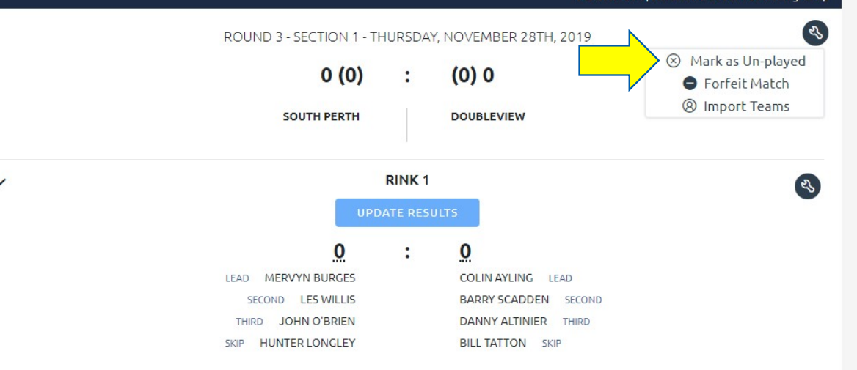
2. Enter a reason as to why the match has been UN-PLAYED
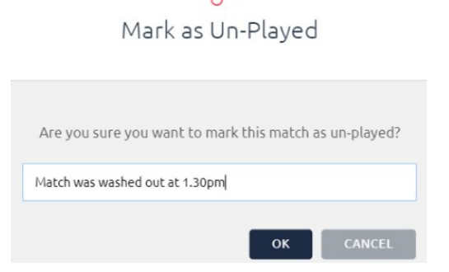
3. Make sure you click FINALISE or CONFIRM
Points Allocation – points are split between clubs
Forfeit/Walkover The Scheduled Home Team must complete these actions wit Away team confirming
1. Use the ACTIONS (at the top of the page) and select FORFEIT MATCH NOTE: This can only be performed by the HOME team
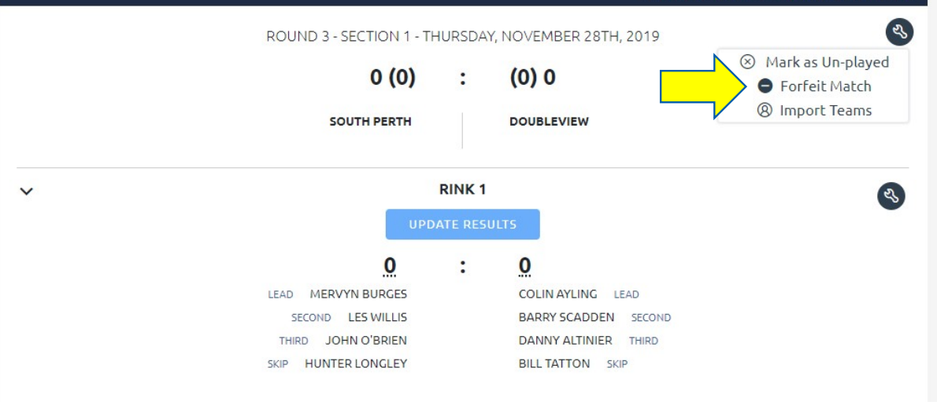
2. It is important to select the correct TEAM that is forfeiting. All players allocated to that team will be removed from this match.
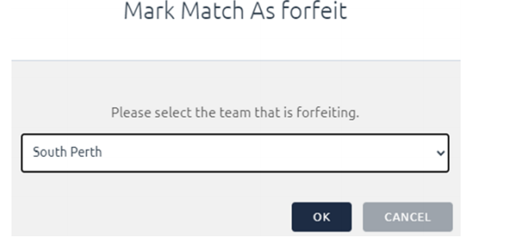
The BowlsLink system will then allocate Points to the other team as per the competition rules.
3. Make sure you click FINALIZE or CONFIRM if required.

