2020-2021 Pennant

Initial Set Up Of Your Club Pennant Teams

Welcome to the BDBD Pennant Season for 2021. This season we are joining many regions in Victoria in administering the season via BOWLSLINK.
The fixture is already in place and can viewed online by anyone anywhere. After each game the teams and result info is also available in an expansive format where you can view side and rink scores, all the team players, and for the Ladder not only each clubs position but also Skip / Player Ladders – great for the Club statisticians.
As BOWLSLINK may be utilized for National/State and Club events/games every player who enters (or is part of a team) will have the result of the game recorded in their personal profile on BOWLSLINK.

INITIAL SETUP
For each Division each of the participating clubs needs to have a Primary Contact set up. Due to COVID and the delay in Clubs holding AGMs, The BDBD has created a “dummy member” within each club – E.g. Results BALLAN and a National ID number is allocated for the dummy member (all bowlers have a National ID number). If you search your Membership database for “Results” you will find the membership record – Note it may be located in your Archived members area.
Some Clubs already have set up another member to “Manage Entries and Results” and will not need to use the dummy member for the initial set up.
- Identify which members will be able to Enter teams /Manage results for each of your teams and find their National ID number in the Membership database. Write down name and the number. This is required later in the process.
- All Clubs would have received an email some time ago with the dummy member details and a password. If you are not quite sure Sign on to Bowlslink selecting your Club Admin profile the search for “Results”. Note the National ID number. Find the email with the password or contact John Holt or Adrian Graham and it will be resent.
- Login to Bowlslink with the dummy member ID number and password. You will now be at the Membership overview page
- Click competitions
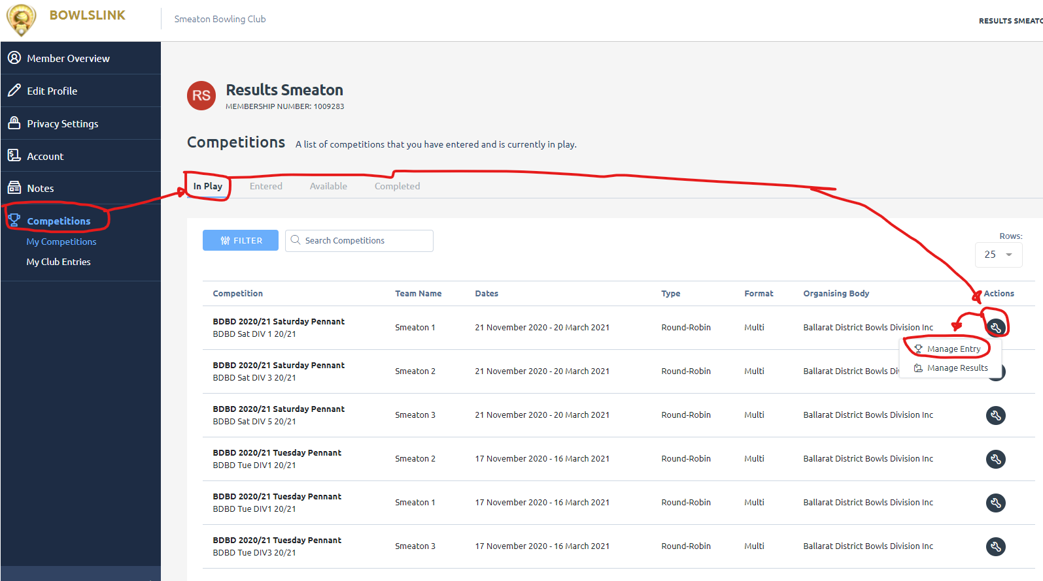
- You should now see a list of the Pennant competitions your club is entered in. If not ensure the IN Play tab is selected.
- Click on the Actions button – far right
- In the drop down box click on Manage Entry
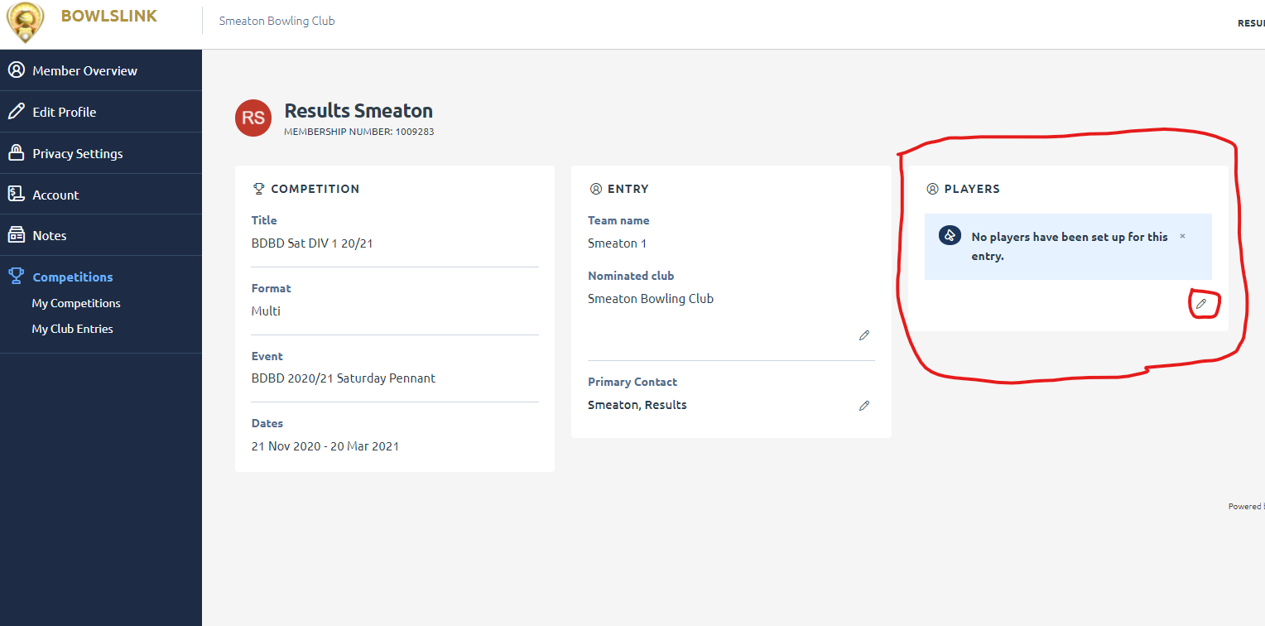
- Find the PLAYERS box – can be in a different position depending on the device you are using
- Click on the Edit pencil
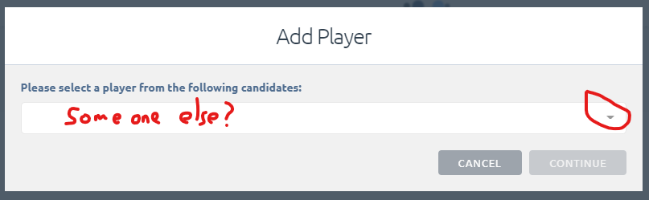
- Click on the drop down Arrow
- Click on Continue
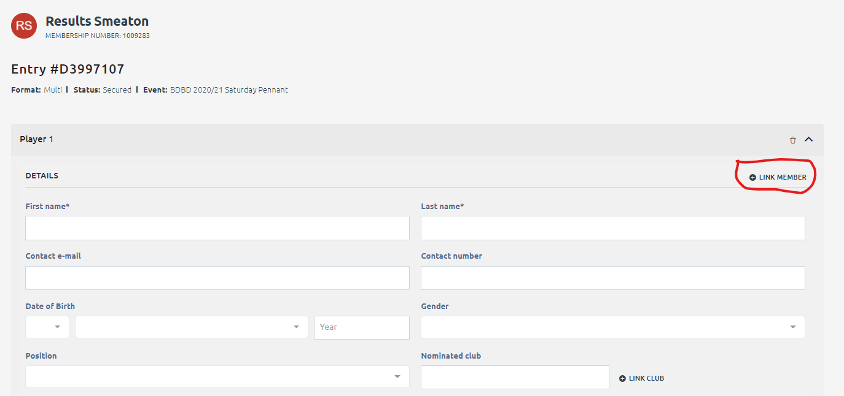
- Click on Link Member-----DO NOT FILL IN THE DETAILS
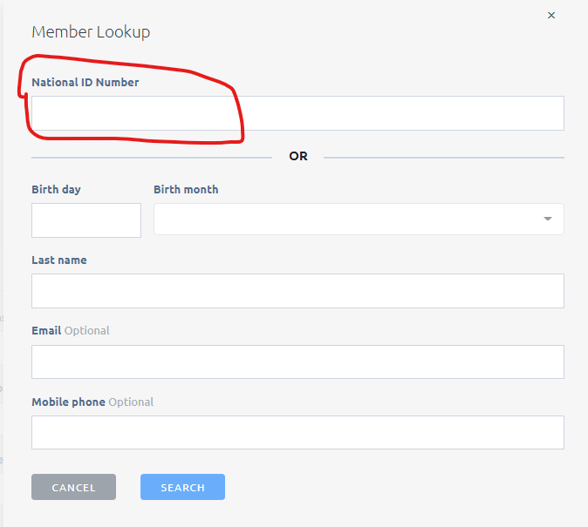
- Enter in the number of the member who you want to manage the entry and results
- Click on Search
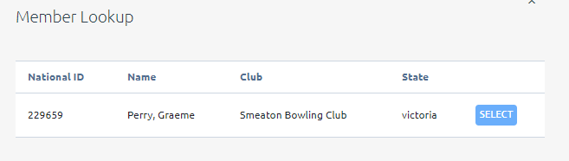
- If this is correct Click Select
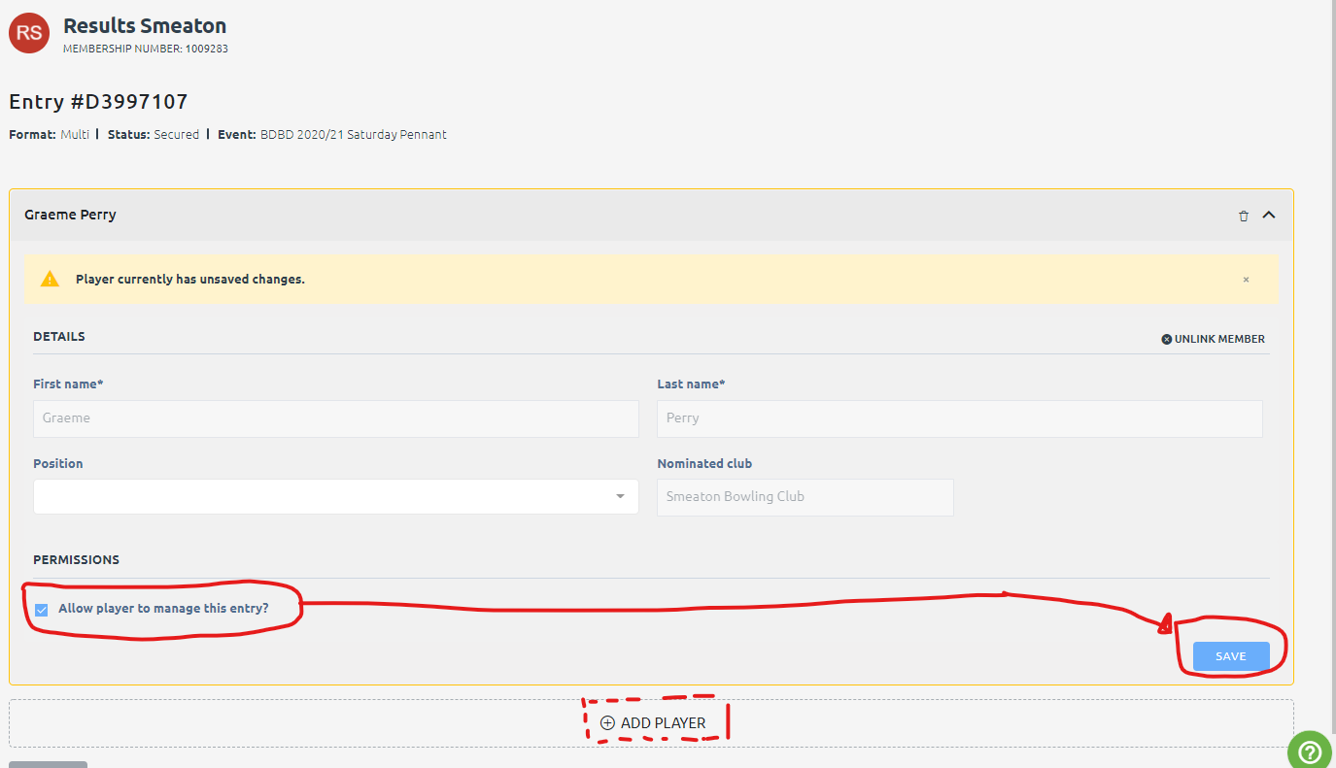
- The Player details appear in the Details area
- VERY IMPORTANT - Tick the box next to “Allow player to manage this entry?” It turns blue.
- Click Save.
- If you want other people to manage This division click ADD PLAYER and repeat the process.
The player(s) whom you have entered can now login and manage that competitions team entry and results.
Repeat for all your competitions
The player(s) you have set up can now login to their personal profile – not as Club Administrator – and set up teams etc.
To learn how to Enter Teams/Results refer to the manual and training video on the BDBD page https://ballaratdistrict.bowls.com.au/bowlslink-info/
If you want to set up Club Championships/Corporate bowls etc. you can do this at the club level but you do need to be set up as a Bowlslink Club Administrator

Tips and Tricks
Now you have managing rights here are some Tips and Tricks
1 Club Fixture.
Login to Bowlslink click on competitions then the Action button and select Manage results
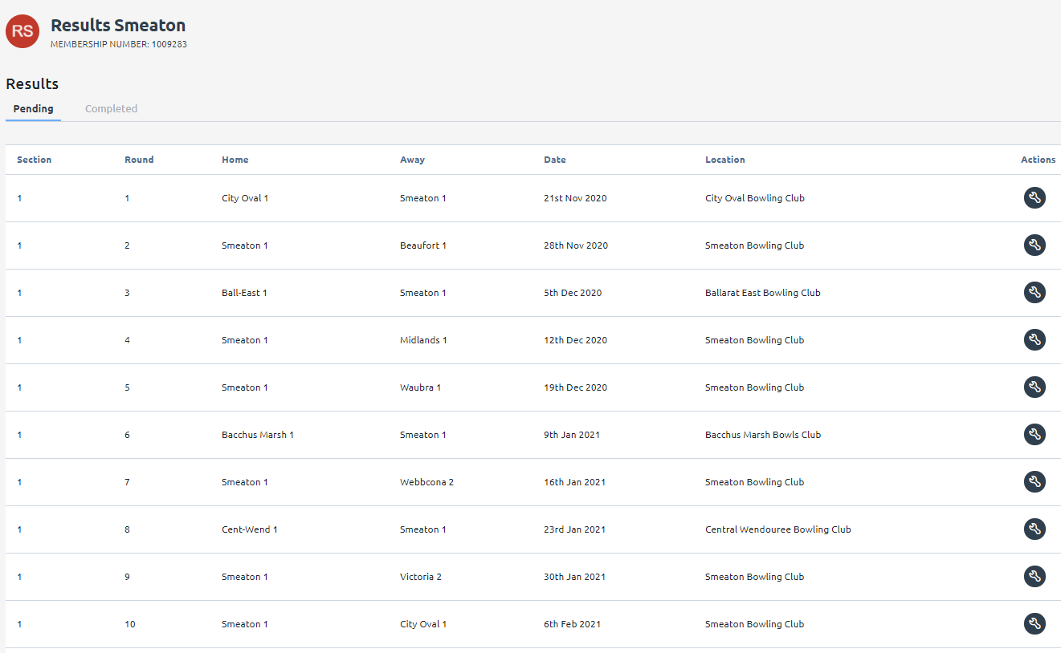
Cut and paste into Excel (or your website) and edit to suit your purposes.
2. View the whole competition
You can refer them to the BDBD Pennant Page https://ballaratdistrict.bowls.com.au/pennant/
Or directly at https://results.bowlslink.com.au/?root_object=competitions&root_id=0402fe28-f1e7-473d-b56b-48888b1c7fa1&root_type=club-group
You may want to set the above as an embedded link i.e. Click here for All Draws and Fixture and make “here” a link using the above.
3. Questions and Answers
Contact John Holt bdbdsec11@bigpond.com or Adrian Graham aghpfm@hotmail.com

